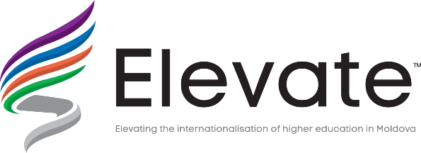

Key Action 2 (KA2) — Cooperation for innovation and the exchange of good practices

Capacity building in the field of higher education (CBHE)

Structural project: ELEVATE-
ELEVATING THE INTERNATIONALISATION OF HIGHER EDUCATION IN MOLDOVA
Reference number: 573921-EPP-1-2016-1-MD-EPPKA2-CBHE-SP
LIST OF PARTICIPANTS
FOR THE STUDY VISIT TO THE BUCKHINGAMSHIRE NEW UNIVERSITY/ 17-22 July 2017
 | UTM
1. | Larisa BUGAIAN | Vice-rector for International Relations
2. | Cristina POPOVICI | Erasmus + Responsible, Faculty of Food Industry
3. | Irina COJUHARI | Erasmus + Responsible, Faculty of Information Technology
 | UASM
4. | Cristina COSCIUG | Head of International Relations Office
5. | Veronica PRISACARU | Vice rector for Academic
 | USARB
6. | Valentina PRITCAN | Chairman of the Committee for international projects and the partnership of the University Senate
7. | Svetlana MELNIC | International Relations Officer
8. | Valentina TURCAN | International Relations Officer
 | KDU
9. | Nadejda IANIOGLO | University lecturer
10. | Maria CARABET | Head of International Relations Office
11. | Oxana MITITELU | International Relations Officer
12. | Tatyana RAKOVCHENA | Vice-rector for Research and International Relations
 | ASEM
13. | Ludmila RURAC | International Relations Officer
14. | Diana BRAGOI | Scientific secretary
15. | Rodica CRUDU | ELEVATE`s manager for academic and scientific issues
16. | Olesea SIRBU | ELEVATE`s Coordinator
17. | Ludmila PAVLOV | Ministry of education

